Assessment of visual functioning in infants

I have given this lecture numerous times over the years. The contents of the present lecture follow the newly edited version of the Guidelines for the Finnish Health Care Centers where the health care nurses follow the development of children. As a part of the general follow-up of nine visits during the first year visual functioning is observed during each visit. The usual observations on the structure of the eyes, red reflex, strabismus and infections are as they have been since 1970s. Specific new observations and questions to the parent(s) support the development of communication and interaction between parents and their baby. In early communication vision has a dominant role.

This lecture was given as a one hour lecture on the 12th of October at the USF School of Nursing in Tampa, Florida.

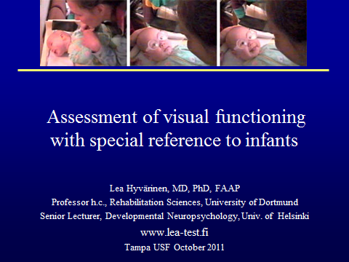

Slide 1. The cover slide with the usual information of the speaker’s work, address of homepage for further information and the place and time of the talk.

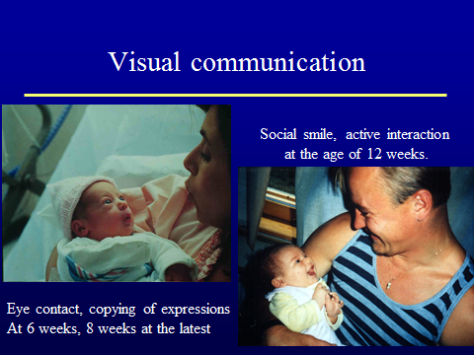

Slide 2. Visual communication. Eye contact develops in typically developing infants during the first weeks of life, sometimes in the first few days as in the infant in the picture on the left. She was also able to copy facial expressions during her second day of life, which is rare. In all countries we expect an infant to have good eye contact at the age of 6 weeks. If that is not found and the infant seems to be healthy, two more weeks may be waited. If the eye contact has not developed, the infant should be assessed without delay by an ophthalmologist. If eyes are found normal, the infant needs to be referred to a pediatric neurologist whose examinations should unravel why the infant’s brain is not using visual information.

Social smile develops at different ages and should be present at the age of 12 weeks at the latest. Eye contact and visual communication between the parent, usually mother, and the baby are noticed when meeting with them in the waiting room. It becomes almost a reflex whenever we meet a child.

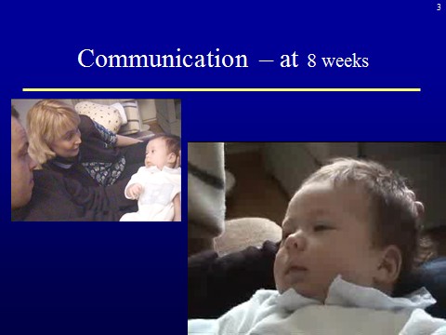 video

Slide 3. Communication – at 8 weeks. Before the infant develops the social smile she may have very active, serious communication with her parents, both parents at the same time. The infant may have great difficulties in pronunciation but she tries hard and it is obvious that she has a message. That we do not understand its content in detail, is our weakness or fault, not that of the baby.
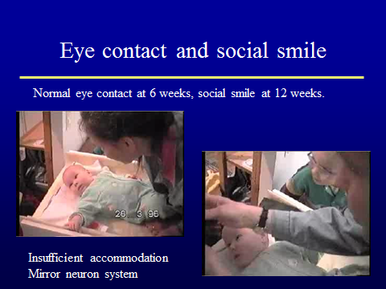2 videos

Slide 4. Eye contact and social smile. If an infant has such an unusual behavior as this 4-month-old girl, the situation should be assessed without delay. As you see in the video, the girl refused to look at her mother’s face. Her eyes were normal and her refraction was weak farsightedness, which is normal at this age. The abnormal finding was lack of focusing, accommodation. Her pupils did not become smaller when fixation targets were moved closer her eyes and the eyes did not converge, move closer to each other. With my retinoscope I could not see any change in the infant’s refractive state (i.e. focusing). Therefore her vision was supported with +4 “reading glasses” to allow her to have a clear image on her retinas. As you can see in the video, the clear image triggered normal fixation, obvious surprise and then a normal social smile for the first time. This revealed that weak accommodation was the cause of the unusual, worrying behavior, not abnormal development of the mirror neuron system .

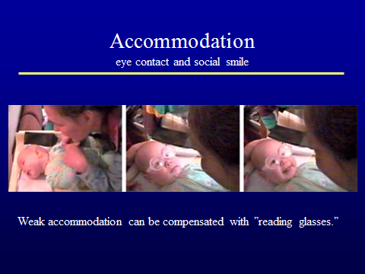

Slide 5. Accommodation, eye contact and social smile. Please, remember these three pictures whenever there is something worrying in the early communication. Accommodation problems are common and are easily taken care of without delay. If the communication situation becomes only a little better, the family should be referred to a pediatric neurologist for thorough investigations. Communication and interaction are important in early development. Infant’s social smile brightens the family’s day and is a strong bonding factor. If it does not develop, other communication avenues should be taught to the family as an integral part of early intervention without delay.

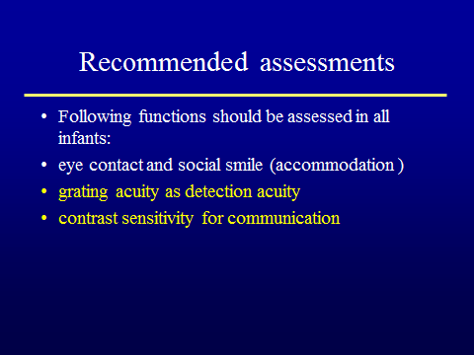

Slide 6. Recommended assessments. If there seems to be delay in the development of visual communication, ophthalmologists can use simple tests to start a more careful follow-up of the development of vision. Visual acuity can be measured as grating acuity, which means that a grating and a grey surface are simultaneously presented to the baby. We watch the baby’s eyes in this situation because a typical reaction is looking at the surface where there is more to see, i.e. the grating. This is called preferential looking situation.
Another easy test situation that tells even more about baby’s vision is the Hiding Heidi test. If the infant looks at the smiling face and smiles, we know that (s)he must have seen the picture, has perceived the smile and was able to “mirror” the smile (a function related to the mirror neuron system).

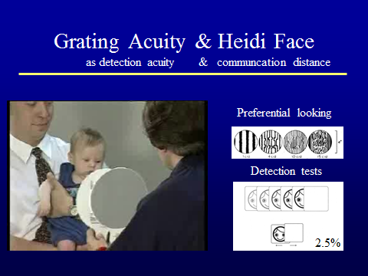 video

Slide 7. Grating acuity & Heidi Face. The sequences of the measurement are short so watch the video twice. First you see the grating “paddles” and then the Hiding Heidi test in assessment of vision of a 3-month-old baby. If an infant responds to gratings, it means that the infant responded to a surface with more visual information. It should not be taken as a sign that the infant saw the grating lines as we see them. They can be as badly distorted as the lines in the upper right hand part of the slide and the baby will still respond.

Hiding Heidi test is easier to interpret. With it we can measure at which distance the baby responds to the low contrast faces that are important in perception of facial expressions. On fair Nordic faces and very dark faces the fast moving shadows are at low contrast, so starting with the high contrast picture we quickly go to the lower contrast pictures. The test distance is first a bit more than our usual communication distance until the baby does not notice the picture any more or we have reached 2.5% contrast level (printed in the corner of the picture). When the baby does not respond, we test with the same picture closer to find the contrast level and distance where the baby can respond to a picture of a 2.5% contrast face. It is important to observe the communication situation between the baby and the mother when the mother has good make-up. Does it help?

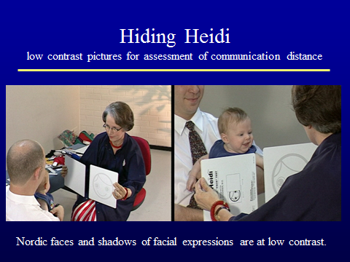

Slide 8. Hiding Heidi. This quick and easy test situation shows the baby’s ability to respond to a smiling face. By moving further away from the baby we find the farthest distance where the baby still responds. That is the outer limit of the communication space. Optimal communication distance is half of the longest distance or closer. Whenever you are so close that the small hands can explore your face you become much more concrete and understandable than through visual information only. With our hands we learned to see.

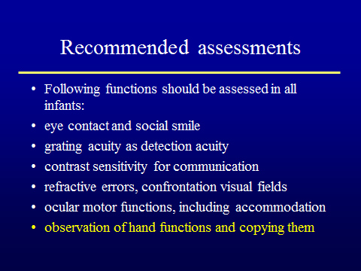

Slide 9. Recommended assessments, 2. Ophthalmologists routinely measure refractive errors and if the errors are bigger than in typically developing infants, glasses are prescribed if needed. The outer edges of visual field can be measured to make sure that there is no large loss of peripheral vision, especially in infants with delays in motor development. Ocular motor functions can also reveal features that guide the examination of delay in communication.

In all infants, including those with normal development, we observe vision and vision related functions when the baby is following the hand movements of other infants. At the age of three months most infants find their own hands, spend hours looking at them, and bring them into the mouth and to midline to touch each other. This is an important function for further development of motor functions. When the baby has found his hands he starts to watch hand movements of other children and adults although (s)he cannot yet perform those movements.

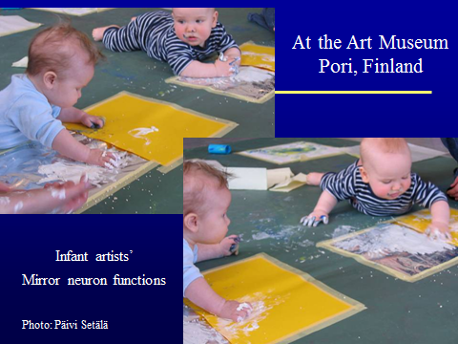

Slide 10. Infant artists. At the age of six months infants enjoy play situations where they can observe other babies’ hand functions and copy them. Pori Art Museum in Finland arranges these play situations for infants. When they have the strength to support their body on their arms on the floor they can join the other little painters.

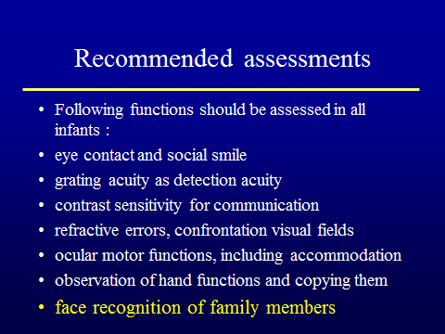

Slide 11. Recommended assessments, 3.At the age of 7 to 8 months many infants recognize their family members when they come close to the child without saying anything. If the infant responds first only when the family member says something, infant’s vision needs to be assessed. It could be a refractive error or a visual pathway problem causing such a poor quality of the image that recognition is not possible. It can also be a more rare cause ; lack of face recognition because that area on the brain cortex does not function. In both situations a thorough neuropediatric investigation is needed after the ophthalmologist’s exam.

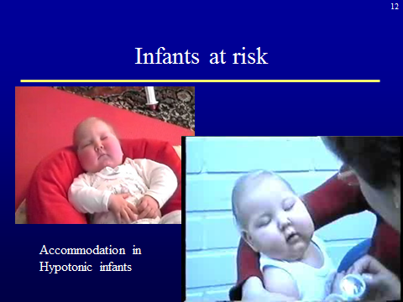 video

Slide 12. Infants at risk. Infants with developmental problems are the largest group of infants with delays in the development of visual functions. If an infant has infantile spasms, the basic disorder and medications make the child tired and thus we need to wait for the moments when the infant is well awake. If we cannot measure accommodation during dynamic retinoscopy and do not see the usual convergence and pupil constriction, then we try with near correction, “reading glasses”. Even severely ill infants can become aware of their vision and for the first time choose to/ actively look at something, as this infant did (video).
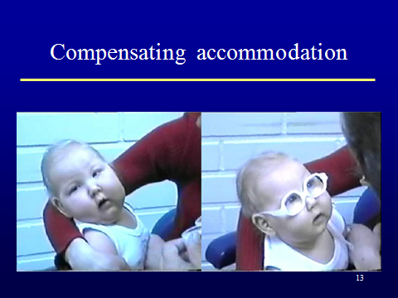

Slide 13. Compensating accommodation. Remember the change that you saw in the previous slide. An infant with no contact with the two people next to her became an alert child and had normal eye contact with an adult. Before this infant had her glasses it was difficult to think that her development would improve. Look at the next picture.

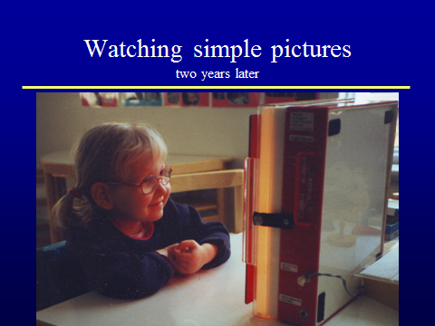

Slide 14. Watching simple pictures. This is the same child enjoying high contrast simple pictures on a lightbox.

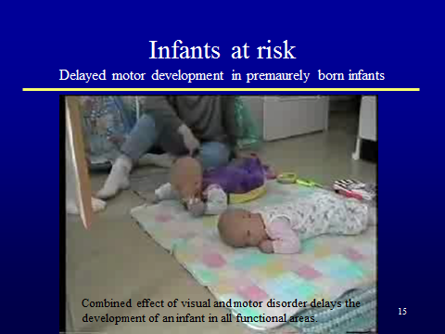

Slide 15. Infants at risk. Prematurely born small infants are a growing group of infants with brain damage related vision loss (CVI). In most cases the delay in visual development is a part of general delay of development due to brain damage before, during or soon after birth. If the damage occurs in one of twins, the healthy twin is the best stimulus but the infant with weak motor and visual functions still needs early intervention with a skilled therapist, in this case a pediatric physiotherapist. If the therapist has not had visually impaired infants in her care, it is mandatory that a vision specialist is involved in the beginning to include vision in the early motor intervention.

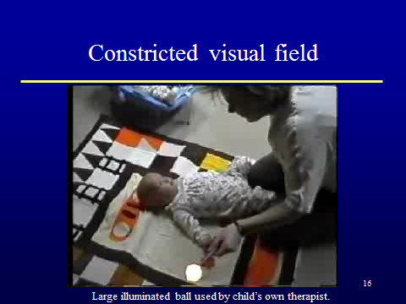 video

Slide 16. Constricted visual field. Since these infants have experienced so many times a new type of pain when there was a new voice, it is wise to start the assessment so that the infant’s therapist (or nurse in the hospital) uses a thin plastic ball on a penlight to assess the visual field as the area of attention. This infant responded only at midline. If we see such a limited functional visual field, we use the hands to make the infant aware of vision: the therapist places first the better functioning hand and then the hemiplegic hand on the ball. The fingers on the illuminated ball form a grating, an effective stimulus for visual pathways and at the same time to tactile and haptic sense.

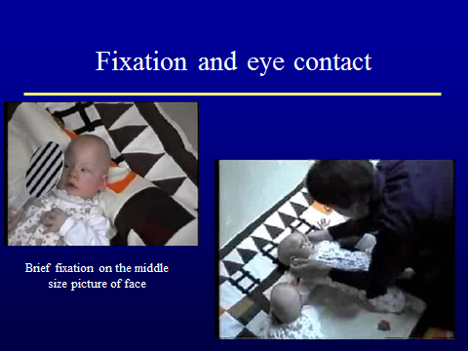

Slide 17. Fixation and eye contact. This infant had only a fleeing fixation to the larger fixation target with face on one and the grating on the other side but she had eye contact with the tester when reading glasses were used.

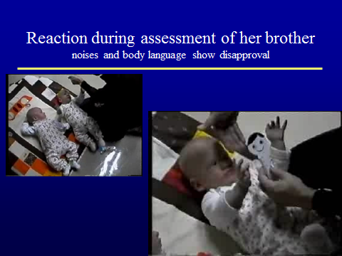

Slide 18. Reaction during assessment of her brother. This girl’s visual functions had seemed to be quite limited. However, when I started to assess the functions of the brother, the girl protested loudly. She was accustomed that new people came for her only and now she was not in the middle of everyone’s interest. Her body language and voice said very clearly that she did not like that at all. Obviously she could see enough to understand what happened around her. She had opinions and she could express them clearly. What more should a baby at the age of five months be able to perform?!

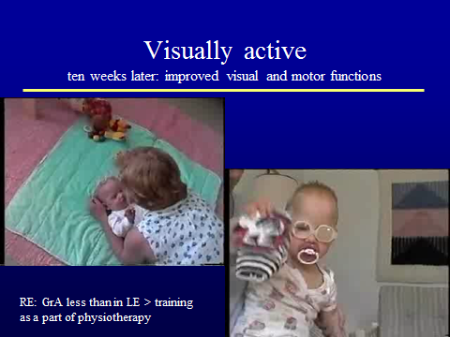 2 videos

Slide 19. Visually active. The baby girl received the test glasses on loan until she received her own glasses that were used all waking hours. She had developed good communication with her therapist. During this visit the consulting therapist learned that the baby had not yet started to turn. Therefore she suggested that the baby’s favorite toy would be used to entice the baby to turn.
A few weeks later her right eye’s grating acuity was less than that of the left eye. To activate the right eye the left eye was patched during training of the right hemiplegic arm and hand and a toy with high contrast details was moved with the child’s own hand. Again the infant’s stimulation is multimodal and performed by the infant herself.

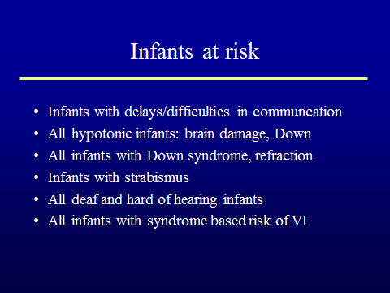

Slide 20. Infants at risk. We follow the development of all children but for children known to be at risk we should arrange a thorough ophthalmological assessment as early as possible during the care of urgent problems. There is usually a calm moment during the day and the infant is well awake. If necessary, the anatomic structures and refraction can be examined in the beginning of an anesthesia for surgical interventions to reduce the number of examinations under anesthesia. Visual functions can be assessed only when the infant can respond.
All hypotonic infants need to be assessed for their accommodation and ocular motor functions because hypotonia may also involve the muscles inside the eye, i.e. focusing.
Infants with Down syndrome are a large well-known group with muscular hypotonia and weak accommodation. They may also have large refractive errors that require correction for clear vision at close distances for communication and finding their hands.
All infants with strabismus need to be examined as soon as there is intermittent turn of the eye. If the correction of the eye turn is possible to balance with strong enough glasses, the infant can further develop her binocular vision. In many cases the usual bifocal correction of inward squint, esotropia, corrects for near vision but not for distance. In such a case we can use near vision correction, reading lens, for the squinting eye to blur the image at distance (called penalization); the infant does not have double vision when looking at distance and amblyopia does not develop.

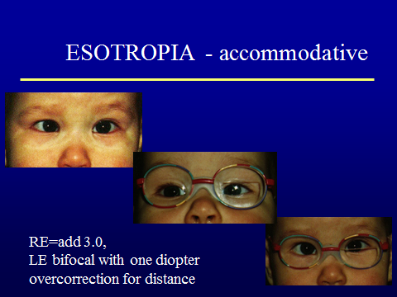

Slide 21. Esotropia. Patching combined with active use of the amblyopic eye, as in slide 19 is useful. If we start early as in the case of the infant in slide 4, combining bifocal correction of the dominant eye and distance penalization of the non-dominant eye can keep the eyes aligned in near vision and prevent diplopia in distance vision, so only short patching for observation that the infant uses her eyes equally is needed. When it becomes possible to document stereovision with the Lang test at the age of 10-12 months and later with more sensitive stereo tests and visual acuity tests, the follow-up becomes easier.

Slide 22. Infants at risk. All infants with impaired hearing are at risk of having Usher syndrome that combines hearing impairment with retinal degeneration. The retinal cells of animals with similar retinal degenerations have been shown to be sensitive to blue light and UV light so filter lenses may be protective devices from early on. Careful follow-up of the visual functions is important for the functional classification in the future if the present experimental treatments will lead to treatment programs.

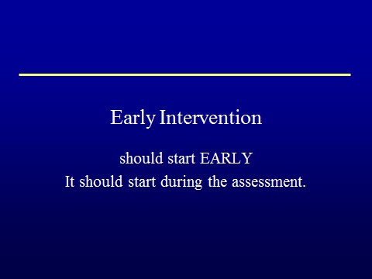

Slide 23. Early Intervention should start EARLY. It should start during the assessment. The observations and assessments are performed for early diagnosis of disorders that impair infant’s visual functioning. With spectacles and modification of visual materials many infants can be helped to see better. Visually impaired children need to learn to effectively use other senses and motor functions to develop optimally. This requires inclusion of vision in early intervention that most of these infants and children have because of their other delays in development. Development of communication and interaction in infants with limited vision requires a skilled early intervention teacher for visually impaired infants as a member of the team and awareness of visual symptoms in all members of the early intervention teams so that infants are referred to a pediatric ophthalmologist or an ophthalmologist who is accustomed to assess young infants without delay. This functions well in several States, which could be used as examples when planning the training of early intervention teams. Early intervention improves the development of visually impaired infants and children in all areas of functioning resulting in new strategies that are important in further learning and integration in kindergarten and school. The child grows and learns to be ready for integration.

However, integration is possible only if kindergartens and schools receive enough information about the development and special needs of children and can include children in their regular or special classes meeting the individual needs of each child. This requires that specialists in education, medicine, optometry, and psychology learn to work together to care for the child with impaired vision and child’s family in a holistic way.

