Importance of Vision for Early Communication
NHSA's Annual Head Start Parent Conference, DEC 10, 2013 in Atlanta

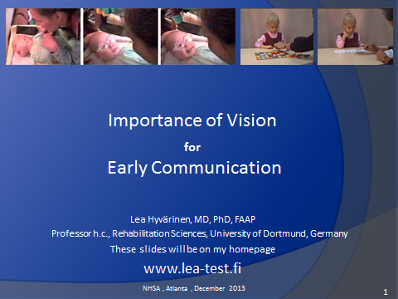
Slide 1. Good afternoon and welcome for this short presentation on Importance of Vision in Early Communication. You have heard that newborn and young infants have poor vision. These statements are based on measurements with broad and narrow black lines that do not interest a newborn infant.
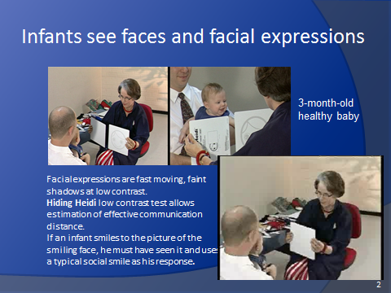
Side 2. Infants are interested in faces and facial expressions that are faint, fast moving shadows on the face of adult persons as we see in this short video sequence. When a card of a smiling face (Hiding Heidi) is moved from behind a white card, a typical 3-month-old infant follows the smiling face with eyes and head turn and responds with a typical social smile. In these few seconds we have observed the baby using numerous brain functions to 1) see the smiling face printed with faint grey lines, 2) to create the complex planning of numerous muscles in the face, and 3) use those muscles to respond with happy social smile. The baby sees faces well, has good vision for communication, and is eager to communicate.
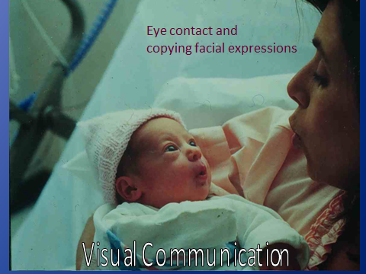
Slide 3. In the first few weeks of life, Visual Communication is based on eye contact and copying facial expressions as we see in this picture taken during the second day after birth.
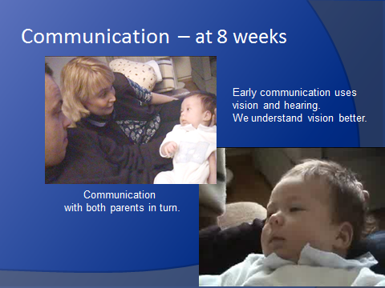
Slide 4. At the age of 8 weeks typically developing infants can communicate visually with both parents in turn and try hard to use voice to express themselves. We understand visual communication better than we understand vocalizations.
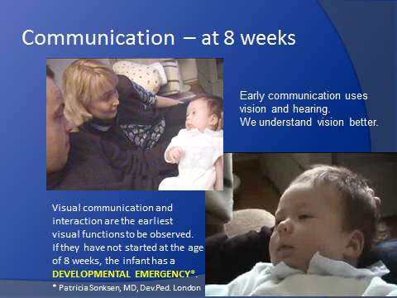
Slide 5. We need no tests but use observation to follow the development of visual communication that is crucial in interaction and bonding. If these functions do not develop, the infant has a developmental emergency and the family is in need of immediate help by persons who know how to assess the infant’s vision, know how to treat, and how to arrange early intervention.
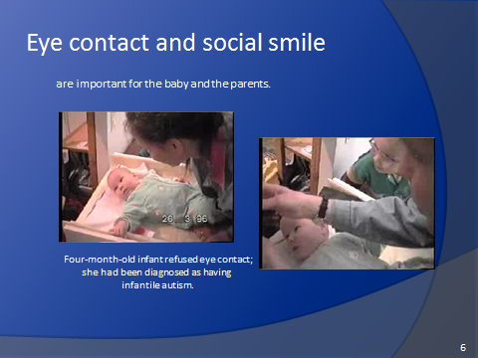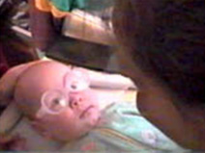
Slide 6. This infant’s mother had great difficulties in visual communication with her 4-month-old daughter who refused communication, turned her head away when the mother tried to have her face in front of the child. I suggested the mother to bring the infant’s hands to her midline because it often helps the infant in holding gaze in the midline. In this case it did not help. It was easy to assess that the infant could not focus the lenses of her eyes (accommodate) and thus images on the retinas of the eyes were blurred.
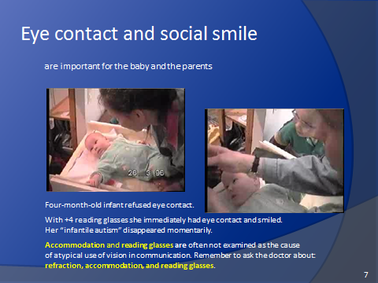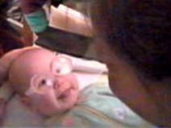
Slide 7. In elderly people we correct such a situation with reading glasses. Similar reading glasses can also help young infants to see clearly so +4- reading glasses were placed in front of the baby’s eyes – and you see what happens: for two seconds the infant looks surprised, then eyes move a little inwards bringing the pictures from the two eyes together and then the infant smiles a typical happy social smile - for the first time in her life. You can hear the joy in the mother’s voice when there suddenly was a visual bridge between her and her child.
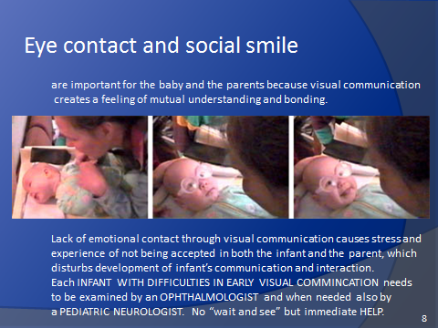
Slide 8. Eye contact and social smile create the feeling of togetherness and bonding. Unfortunately, accommodation is not always measured and some doctors believe that young infants do not benefit from eye glasses. If interaction cannot develop, it causes stress in the infant and the parents, and may derail the emotional development of the infant and the whole family. Each infant with difficulties in eye contact should be assessed without delay.
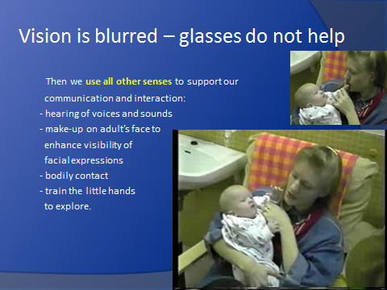
Slide 9. If infant’s vision is blurred and glasses do not make it clear, the infant has impaired vision. In this situation we use all senses to support communication and interaction: hearing, make-up of the adults’ faces to enhance visibility of facial expressions, bodily contact, and help the little hands to explore.
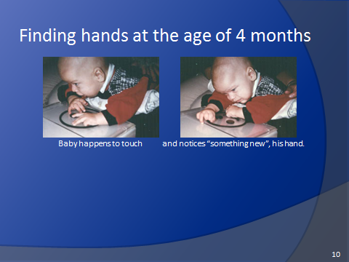
Slide 10. We have all learned to understand what we see by exploring with our hands. This infant had not become aware of his hands at the age of 4 months. Therefore he was helped to notice his hands when placed on this visuo-tactile picture. When the infant touched the raised lines, he noticed his hands and looked at them with wrinkles on his forehead.
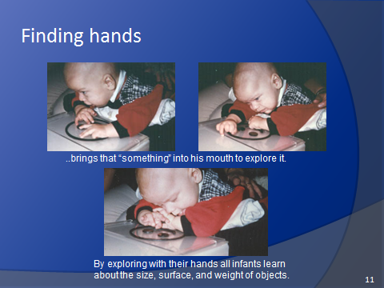
Slide 11. He explored his hands with his lips and tongue to get confirmation of the structure of the new finding. Once aware of his hands he could start using them in exploration of objects and structures in his environment.
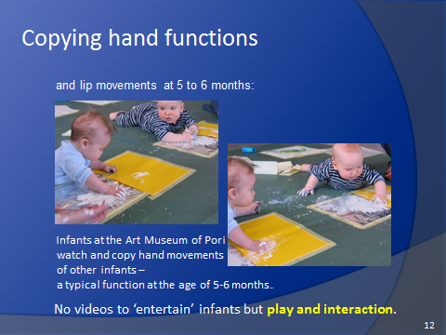
Slide 12. At the age of 5-6 months hand function have developed and infants watch intently lip movement and goal-directed hand movements and copy them, as we see in these pictures where the young artists watch each other’s techniques in “Color Bath” of an art museum in Finland. This play situation is great fun for the infants and their parents.
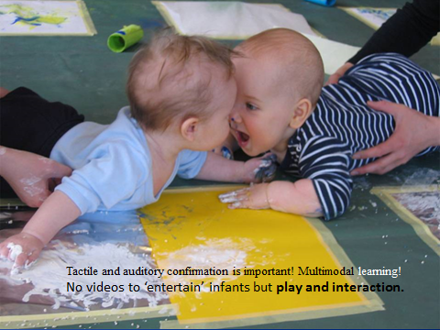
Slide 13. As we see in this picture. If infants learn to be doers and have their parents’ attention and participation, they develop to active children with good communication skills.
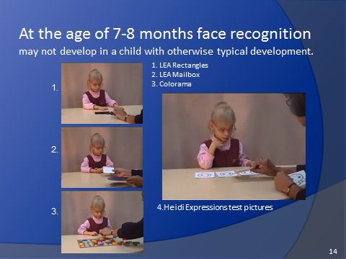
Slide 14. Some children can use their vision in many activities like a typically developing child as we see in these short video sequences on a two and half year old child: 1) LEA Rectangles Game that requires visual concept of length of objects and lines and use of this concept in eye-hand coordination; 2) LEA Mailbox Game for directions of objects and lines; 3) Colorama Game that requires simultaneous use of both form and color information. However when the task was to compare in which of her cards the mouth has the same form as in the tester’s card, she did not understand the questions. She had never seen facial features and knew them only as tactile information. She had Face Blindness.
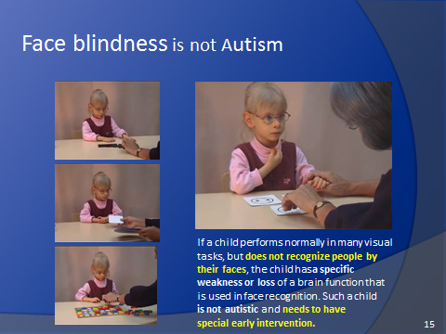
Slide 15. This child had a specific loss of seeing faces. She knew facial structures from exploration with her hands – as tactile structures. The Heidi Expressions pictures did not contain forms that she could recognize. The difficulty varies from no perception of faces to somewhat slow recognition of familiar faces. These children need specific teaching to perform in one-to-one communication situations and group communication like typically developing children. This communication training is rarely available as a part of general early intervention. Persons who care for or teach these children should learn to understand how each child sees and recognizes people. These children are NOT autistic if they look past the person who talks to them because they concentrate in listening and push the useless visual information aside.
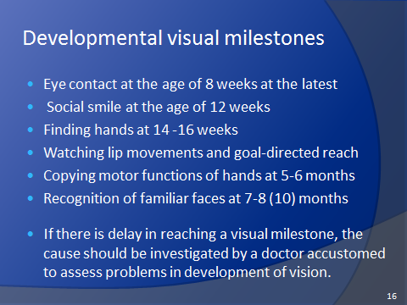
Slide 16. In medicine we are accustomed to look for and treat eye diseases. Development of vision is easy to observe when the variations in the development are known. These children should have good early intervention so that they can develop to actively participating toddlers and children in an environment that understands and supports their development.
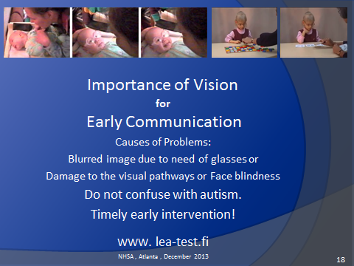
Slide 17. As we have seen, follow-up of visual development requires careful observation of several well-known milestones and knowledge of possible causes whenever there is a delay in reaching a milestone. Although variation in the age of reaching each developmental milestone is great, it is not an acceptable reason for “wait-and-see” attitude. The infant and family benefit from support by early intervention. Especially important is that communication difficulties are NOT called “autistic behaviors” because then the infant is not referred for careful assessment of the causes of problems and correct treatment. The treatment can be as simple as prescribing a pair of glasses, but can mean treatment of an acute disease or a lifelong disorder that requires enhancement and substitution of impaired vision by using all senses for communication and interaction in early intervention,
TIMELY EARLY INTERVENTION.

This lecture will be available with its videos. Let me know if you are interested. lea.hyvarinen(at)lea-test.fi

